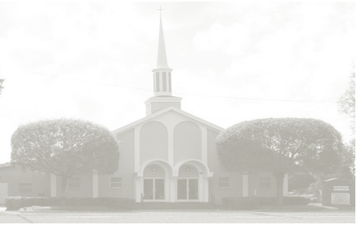
New Hope Missionary Baptist Church
Emergency Food Assistance Program (TEFAP)
Certification of Eligibility to take Food Home

RESPONSES TO QUESTIONS MUST BE PROVIDED IN ORDER FOR APPLICATION TO BE CONSIDERED (PLEASE PRINT INFORMATION)
PERSONAL INFORMATION
Last Name ____________________________________________________
First Name ____________________________________________________
Address: _ ____________________________________________________
City: ____________________________ Zip Code ____________________
Daytime telephone#: ____________________________ Evening telephone#: ____________________
Email: _ ____________________________________________________

Number of People In Household: _______

The attached (or posted) table shows yearly gross income for each family size. If your household income is at or below the income listed for the number of people in your household, you are eligible to receive food. Check below if you meet the established income eligibility.

____________ Income eligibility

You are also eligible to receive food from TEFAP if your household participates in any of the following programs.
If you participate in any of these programs, please place a checkmark in the space (s) next to all that apply.

Please Mark Amount

_______ Food Stamps
_______ Aid to Families with Dependent Children (AFDC)
_______ Supplemental Security Income (SSI)
_______ Residence in Public Housing funded by Municipal, County, State or Federal Government

Please read the following statement carefully and then sign the form and write in today’s date.
You only need to meet one of these requirements to be eligible to receive USDA commodities.

I certify that my yearly household gross income is at or below the income listed on this form for households with the same number of people OR that I participate in the program (s) that I have checked on this form. This certification is being submitted in connection with the receipt of Federal assistance. Program officials may result in having to pay the State agency for the value of the food improperly issued to me and may subject me to civil or criminal prosecution under State and Federal law.

___________________________________ ______________
Signature Date

THIS CERTIFICATION IS VALID FOR A PERIOD OF ONE YEAR

